|  |  |
| --- | --- |
| **Network Infrastructure**  Diploma in CSF/IT  Year 2 (2020/21) Semester 3 | Week **12** |
| **1** hour |
| **Windows Server 2016 : Users Account, Computer Account and Groups** | |

## A. Objective:

At the end of this practical, students should be able to create Windows Server 2016 Users Account, Computer Account and Groups.

**B. Resource**

Microsoft Windows Server 2016 OS Virtual Machine (**VM**) running in VMware Workstation

### C. This week’s tasks

In this practical, a Windows Server 2016 OS has already been installed in VMware Workstation. You have to carry out the following tasks:

Task 1 – Install Remote Server Administration Tools for Windows

Task 2 – Create Users Account

Task 3 – Create Computer Account

Task 4 – Create Groups and Implement Group Strategy

### D. Lab Settings (VM)

In this practical, the following settings would be used:

|  |  |
| --- | --- |
| **Server Name** | WinSvr2016_01 |
| **Client computer name** | NIclient**Y** where **Y** is from 101 to 102 |
| **Company Name** | NI Pte Ltd |
| **IP Address /**  **Subnet Mask** | **For the Server VM (Windows Server 2016):** 172.16.**T**.1, where **T** is Team 2 to 9.  **For the Client VM (Windows 10):**  172.16.**T**.**Y,** where **Y** is from 101 to 102 |
| **Administrator password** | Pa$$w0rd |

**Task 1 – Installing Remote Server Administration Tools for Windows**

1. Download **WindowsTH-RSAT_WS_1709-x64.msu** from MeL Learning Materials – Week 12 Practical onto your computer (Host).
2. Start the Windows 10 VM (**NIClient101)** in the VMware Workstation.

* Login on using NI**T**\Administrator.
* Copy **WindowsTH-RSAT_WS_1709-x64.msu** to the desktop of **NIClient101.**
* **Double**-click on the **WindowsTH-RSAT_WS_1709-x64.msu** to install
* When you are prompted by the Windows Update Standalone Installer dialog box to install the update, click Yes.
* Read and accept the license terms. Click I accept.
* Installation requires a few minutes to finish. Click Close when completed.

1. After installing Remote Server Administration Tools for Windows 10, you can access the tools as follows:

* Go to Control Panel, click System and Security.
* In System and Security page, click Administrative Tools.
* In Administrative Tools page, double-click Active Directory Users and Computers. [Note: WinSvr2016_01 VM must be running]

**Task 2: Create Users Account**

1. On the “**Users**” object of the Active Directory Users and Computer, **right click** and select **New->User**
2. Enter **NIuser1** as shown in Figure 2.2 and click **“Next >”**

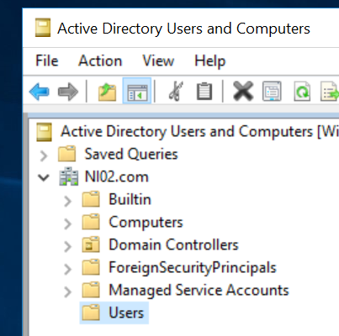 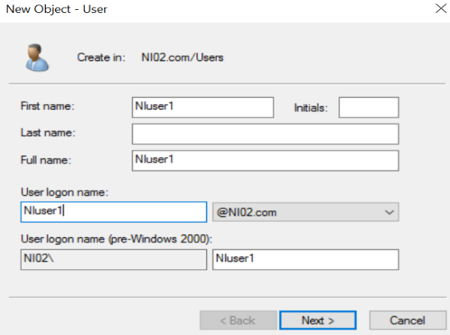

Figure 2.1 Figure 2.2

1. Type “**Pa$$word**” in the password box and check “**User must change password at next logon**”. Click “**Next >**” to continue.

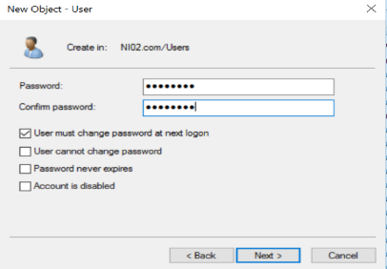  
 Figure 2.3

1. Click **“Finish”** and the user, **NIuser1** will be created as shown in Figure 2.4.

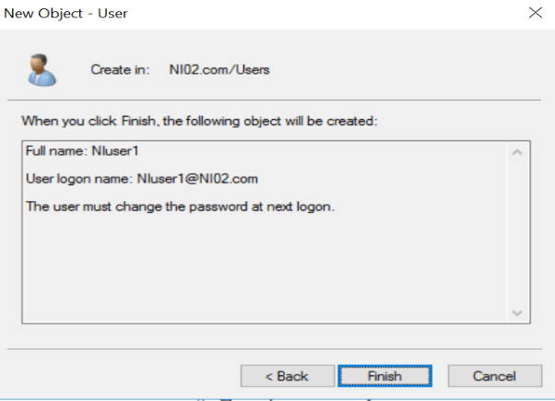

Figure 2.4

**Task 3: Create Computer Account**

1. Click on the “**Computer**” object of the Active Directory Users and Computer, notice that **NIClient101** was added automatically when it joined NIT.com domain.
2. You can manually add a computer as follows:

* On the **“Computer”** object of the Active Directory Users and Computer, **right click** and select **New->Computer**
* Enter **NIClient102** and select **“OK”** as shown in Figure 3.2

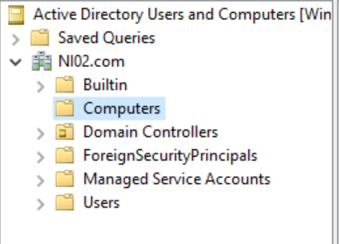 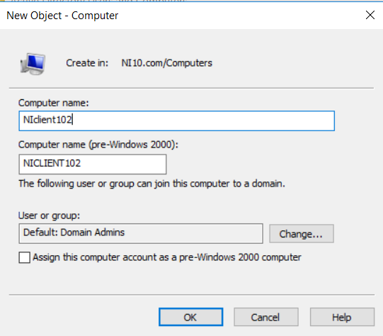

Figure 3.1 Figure 3.2

**Task 4: Create Global Group and Implementing Group Strategy**

1. On the “**Users**” object of the Active Directory Users and Computer, **right click** and select **New->Group** with **Group scope** as **“Global”** and **Group type** as **“Security”**.
2. Enter **Students** as shown in Figure 4.1 and click **OK**

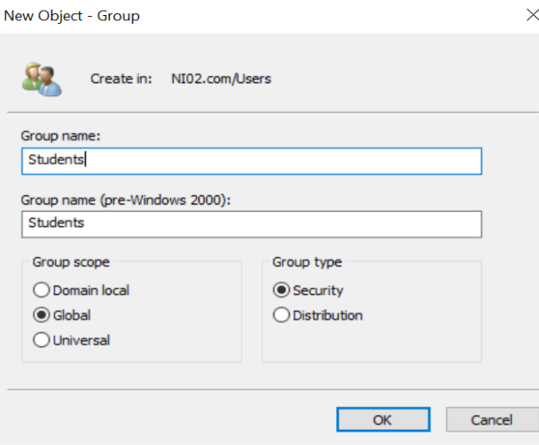

Figure 4.1

**Adding NIuserx** to **Students Group**

1. **Double** **click** on the **Students** group you created, then click on “**Members**” **tab** to add new members.
2. Type **NIuser1** and select “**Check Name**”. If the member is found, click “**OK**”as shown in Figure 4.3

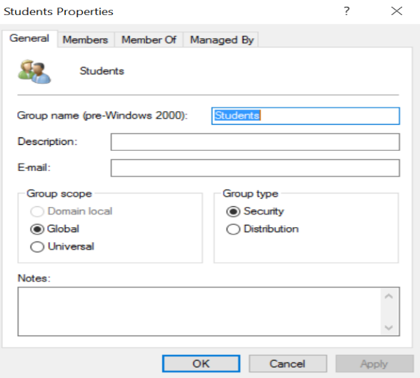 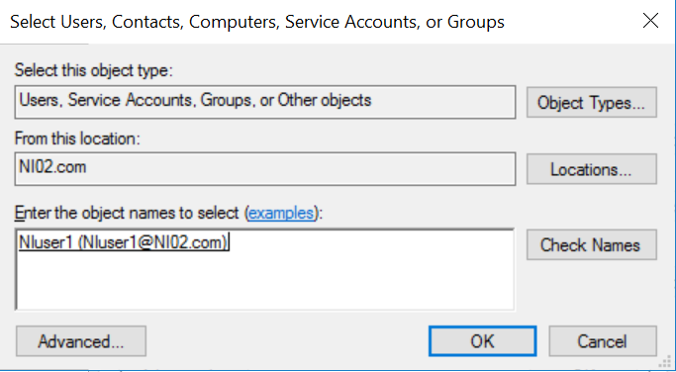

Figure 4.2 Figure 4.3

1. On the “**Users**” object of the Active Directory Users and Computer, **right** **click** and select **New->Group**. Enter **Local HP Printer with Group scope** as **“Domain local”** and **Group type “Security”** as shown in Figure 4.4. Select “**OK”** when done. (**Local HP Printer** Group is created)
2. Open **Local HP Printer** Group, click on “**Members”** tab. Select “**Add**” to add members or groups.
3. Type **Students** and select “**Check Name**”. Once done, select “**OK**”as shown in Figure 4.5

**Students** group (Scope: **Global**) is added to the **Local HP Printer** Group (Scope: **Domain local**)”

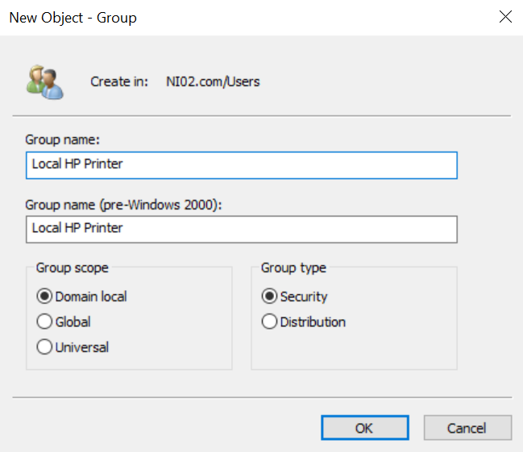 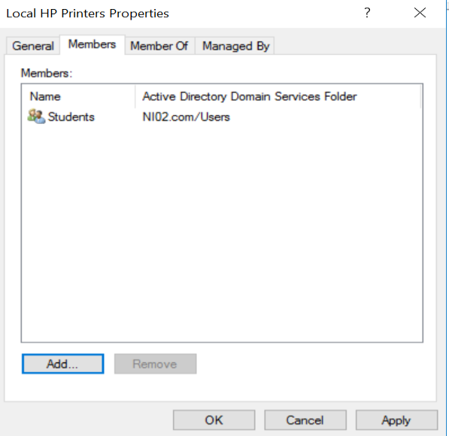

Figure 4.4 Figure 4.5

********* End of Practical **********